|  |  |
| --- | --- |
| Image result for csueb logo | **Data Warehousing and BI** |
| **Chenwei Cao** |

**Objective**

I will create a Utility data warehouse consisting two fact tables and two dimension tables. I will then create a cube from this database and perform a drill-across operation by combining the measures from both fact tables.

**Database and Cube**

Following two databases are provided to you, each contains two flat files.

*ElectricityBills*

1. Residents (AccountNumber,LastName,FirstName,Street,Apt,Zip,ElectricityMeter)
2. Billing Cycles (CycleID,AccountNumber,CycleDate,Rate,ElectricityUsage,UsageFee,PaidDate,AmountPaid,AmountDue)

*WaterBills*

1. Residents (AccountNumber,LastName,FirstName,Street,Apt,Zip,Phone,WaterMeter)
2. Water Bills (BillingID,AccountNumber,BillingDate,Rate,Usage,Billing,PaidDate,AmountPaid,AmountDue,Audited)

Create a Utility database containing two dimensions: DimResident and DimDate; and two fact tables: FactElectricityBill and FactWaterBill. Populate these tables from the flat file data and create relationships. **Take a screenshots of the SSIS data flow models used to insert the data.** Remember to appropriately name the tools used in the data flow. **Take a screenshot of the database diagram.** Create a cube named Utility from the database. **Take a screenshot of the cube structure.**

1. **Here are my screenshots of the SSIS data flow models used to insert data.**

1. **Here is the output of DimResident table after inserting data:**

1. **Here is the output of FactElectricityBill table after inserting data by using SQL query:**

1. **Here is the screenshot of my output of FactWaterBill table after inserting data:**

1. **Here is the screenshot about my Utility database diagram contained two dimensions: DimResident and DimDate; and two fact tables: FactElectricityBill and FactWaterBill.**

1. **Here is a screenshot of my Utility cube structure.**

**Drill-Across Operation (3 points)**

Perform a drill-across operation using MDX query or otherwise to find the total amount due (i.e. sum of due amounts in electricity and water bills across all months) and total amount paid (i.e. sum of paid amounts in electricity and water bills across all months) by each account number. The partial output of the MDX query is provided below for reference.

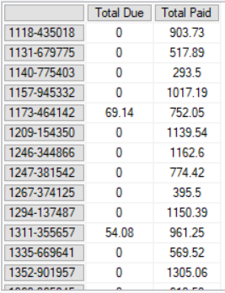

1. **Here is screenshot of my drill-across operation using MDX query to find the total amount due and total amount paid by each account number.**

